Mount-up in the Mountains
Competitive Trail Ride
June 13 - 15, 2024
Information Sheet

June 13 - Check in/Vet Check
June 14 - CTR Competition/Supper/Firepit
June 15 - Break Down Camp/Pull Flags

NOVICE – 25 miles INTERMEDIATE – 25 miles OPEN A - 50 miles
• Lightweight ($80) • Lightweight ($80) • Lightweight ($80)
• Heavyweight ($80) • Heavyweight ($80) • Heavyweight ($80)
• Junior ($50) • Junior ($50) • Junior ($50)

TRAC sanctioned ride, all entries include $10.00 sanctioning and drug testing fee.
Camping fees are $30 per person flat rate for the weekend
Contact Amy or see the TRAC Facebook page for an entry form!

Link to Entry form:

https://docs.google.com/forms/d/e/1FAIpQLSeBNVSH5EN7vkaSTWTF5feIGy-jnrBDEKQPt0ykJDrWBCmXJw/viewform?usp=preview

Please send your entries and payments to Amy Nelson - mountupinthemountains@gmail.com

The ride will be held near Ghost River, AB, just west of Cochrane on Highway 1A and north on the Forestry Trunk Road #40. See directions to ride camp below.

This is a 1 day ride with a Novice, Intermediate and Open divisions. Friday’s registration will begin at 3 pm with initial vet in beginning at 4 pm. You must arrive on Friday to be vetted in for Saturday’s Ride. Please send in your entry forms by Monday, June 9th.

Most of this ride would be considered back country travel - if you have a communication/satellite device you are encouraged to bring it to use in case of emergency. This ride will have HAM Radio personnel along the course to help with any communication or emergencies.

Hoof Protection is strongly recommended as there are riverbed crossings and rocky conditions.

All participants must be AEF members prior to the ride for insurance purposes. Please have this done before you arrive and bring proof of membership with you. It is the rider’s responsibility to be familiar with the rules. The TRAC handbook can be found at http://www.trailriding.ca/resources/trac-handbook.html Every participant is required to always wear a helmet when mounted, even in camp when not competing.

Volunteers are always needed. If you can help out please contact Amy Nelson (403) 678-0410. Meals will be provided for all Volunteers and Vets - Volunteers do NOT have to pay a camping fee. Supper on Saturday is complementary (sponsored by Nelson Valley Farms) and will be Taco Salad. Please bring your own mugs, plates and utensils.
Contact for Mount-Up in the Mountains TRAC ride is Amy Nelson (403) 678-0410 or mountupinthemountains@gmail.com
Directions to the Campsite
*Best suggestion is pin Saddle Peak Trail Rides onto your google maps **

From Cochrane, going west on Highway 1A, turn right (north) onto highway 40 (towards Waiparous Village). Follow Highway 40 through the Village of Benchlands and Waiparous and then past Capture the Flag Paintball on your right hand side. Just Past Capture the flag you will see the sign for Richards Road. Turn West (Left) onto Richards Road. 1km down the road there is a one-way bridge. Go straight across. Camping is about 3 km past the bridge on the left-hand side. LOOK for signs. If you go past you will need to go into Saddle Peak Trail Rides at the end of the road and turn around.

Camping Rules and Regulations
- This is primitive camping with no cell coverage and limited toilet facilities
- If you have the ability to bring a bulk amount of water for your horse, please do so.
- Please remove all garbage and waste including soiled Hay.
- Manure can be spread
- Please be respectful of the land, this is private property and the owners have been gracious enough to let us use their property.
- Dogs are ok - their waste must be picked up and they must be under your control at all times
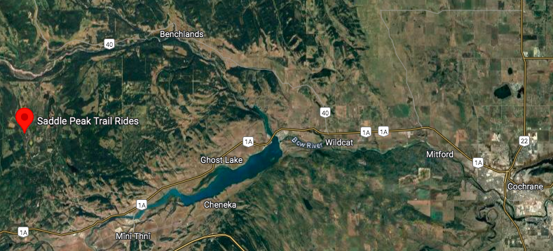
- There are no holding pens, please bring your fence, panels or highline for your horses

