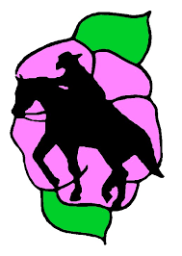
Trail Riding Alberta Conference (TRAC)
Introduction to
Competitive Trail Riding Clinic

Date: May 10, 2025
Location: Red Lodge Guest Ranch, Bowden AB

Interested in Distance Riding but don’t know where to start?
This clinic will be a great introduction to the Competitive Trail Riding (CTR) sport.

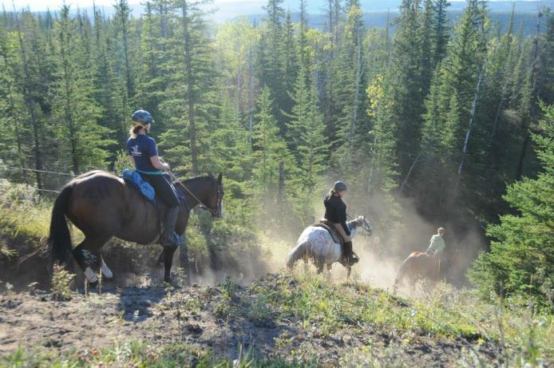
CTR Discussion Topics Covered:
*Trail Etiquette
*Vet Checks Pulse and Respiratory Recovery
*Equine conditioning
*Followed by a 5mile mock CTR & Vet check

Registration Fee: $40.00

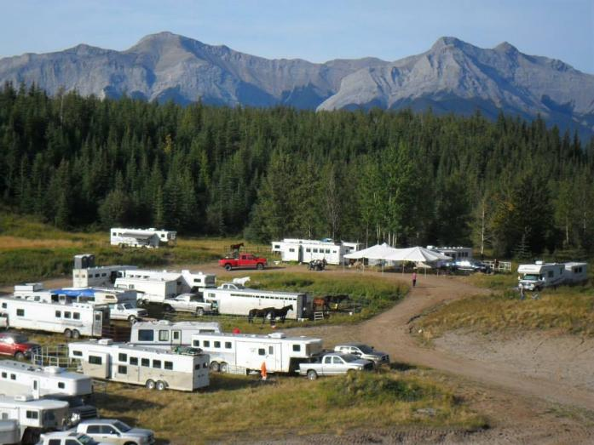

Limited to 30 riders

Helmets are mandatory for all riders while mounted

Camping with your horses is available Friday and Saturday night
Red Lodge Guest Ranch at 403-224-3082

Coffee and Snacks provided

To register or get more information please contact Adrianne at adriannewilson89@gmail.com or check out our website at www.trailriding.ca

