Bar J Bustle Competitive Trail Ride
Aug 31-September 2, 2023
Information Sheet

The ride will be held southwest of Water Valley Alberta

This is a 2-day ride with an Intro, Novice, Intermediate and Open divisions. Friday registration will begin at 3 pm with initial vet in beginning after 4 pm. Please arrive on the Friday for the ride on Saturday. If entering the same division with the same horse on Saturday and Sunday, your Saturday vet out will be used as your vet in for Sunday. Any other variation of registration will require you to vet in on Saturday afternoon to ride on Sunday. Day 2 is a “no frills ride”, meaning that there will be no prizes awarded, you will still earn placings and points for year end awards.

Please send in your entry forms by August 25th. Late fees of $20 will be applied to entries received between August 26th and Aug 28th. No entries will be accepted after Aug 28th at midnight.

If you are planning to ride with someone or have a preference on where you start in the division (front or back of the pack), please indicate it on your registration form to make organizing out times easier for the ride secretary. We will do our best to accommodate requests.

Footing is mostly grass, dirt and forest floor with rocky river crossings and some rock on dirt road. Hoof protection is optional based on each individual horses’ needs.

All participants must be AEF members prior to the ride for insurance purposes. Please have this done before you arrive and bring proof of membership with you. It is the riders’ responsibility to be familiar with the rules. The TRAC handbook can be found at http://www.trailriding.ca/resources/trac-handbook.html

Every participant is required to always wear a helmet when mounted, even in camp when not competing.

Volunteers are always needed. If you can help out, please contact Daniella Harding. Lunch and supper will be provided for volunteers and vets only. Please bring a potluck dish for Saturday evening so we can enjoy summer together! Please bring your own mugs, plates and utensils.

You are responsible for your own garbage – please take it home.

Contact for TRAC ride is Daniella Harding at 403-797-3263 or daniella.harding@hotmail.com

Detailed directions will be sent out to participants after they are registered for the ride. Located SW of Water Valley with good road to ride site. Road down into property is a fairly steep winding but solid road. Please go slow, especially those with larger truck trailer combinations. There is one bride to cross that can appear narrow but with proper alignment is crossable for any size truck trailer combination.
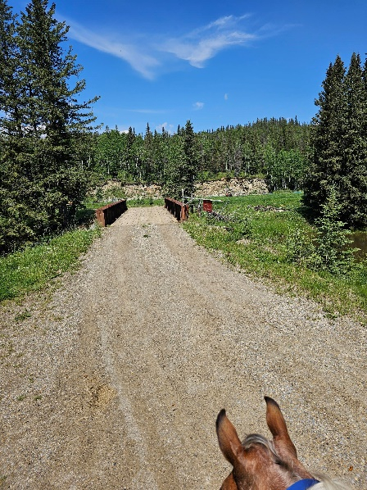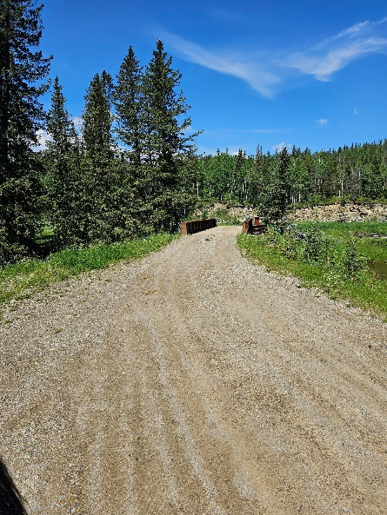

Camping Rules and Regulations

Please remove all garbage and waste including soiled Hay.

Manure can be spread.

Please be respectful of the land this is private property and the owners have been gracious enough to let us use their property.

We thank you for your cooperation on all the above items if all goes well more rides at this site will hopefully be in our future!

Ride Details

This is a challenging ride with a lot of elevation gain, the trails are not overly technical but is not a walk in the park. The trail will be 22-23 miles in length and have a 3500 feet of elevation gain.

The intro ride will be 10 miles and 1035 feet elevation gain.

Ride with GPS
New this year we will be using Ride with GPS, a free (for you) app for both Iphone and Android that is easy to use and extremely handy for ensuring accurate trail riding for you. The trail will be traditionally marked but you will also be provided trail maps for each loop on the app. Ride with GPS provides you with the ability to download the map ahead of time and then use during the ride. With a maker to show where you are on a trail, cues both written and verbal to give you warnings when there is a turn or an important point on trail as well as sound notifications that will alert you when you have gone off trail.
I will give detailed instructions in how to use it in the rider info packet after you have registered. I know new technology can be hard to accept but I think this can be extremely beneficial to both riders and ride managers.

If you have any questions please contact Daniella at daniella.harding@hotmail.com
See you on the trails!!!!

